CS 255 System Design Document

UML Diagrams

UML Use Case Diagram
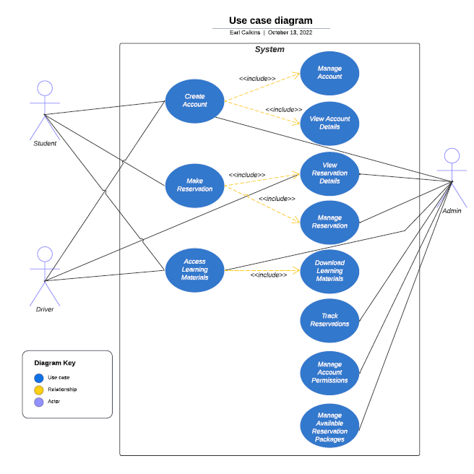

UML Activity Diagrams
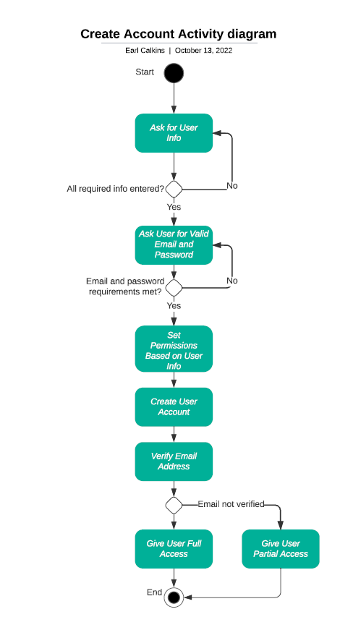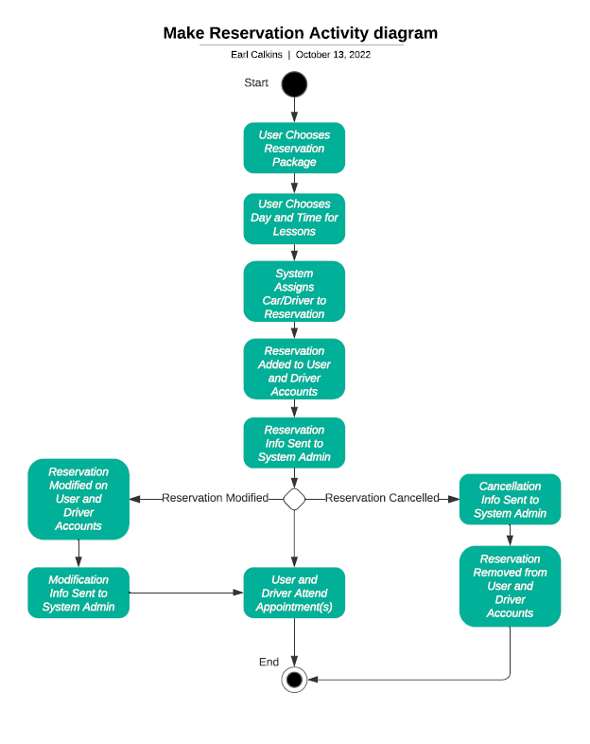

UML Sequence Diagram
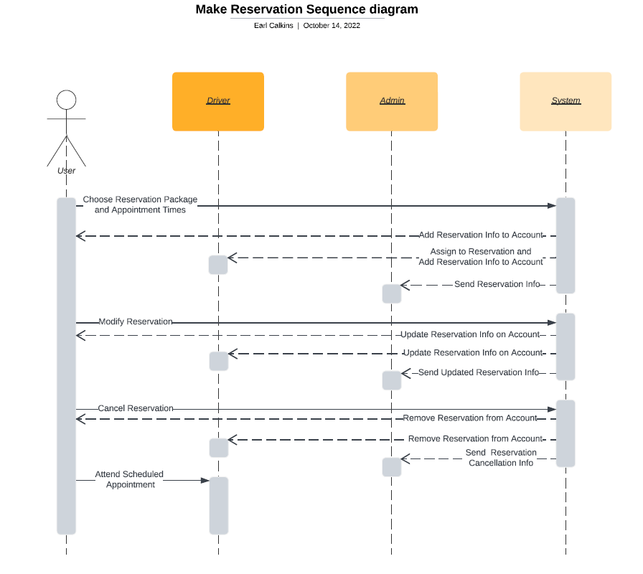

UML Class Diagram
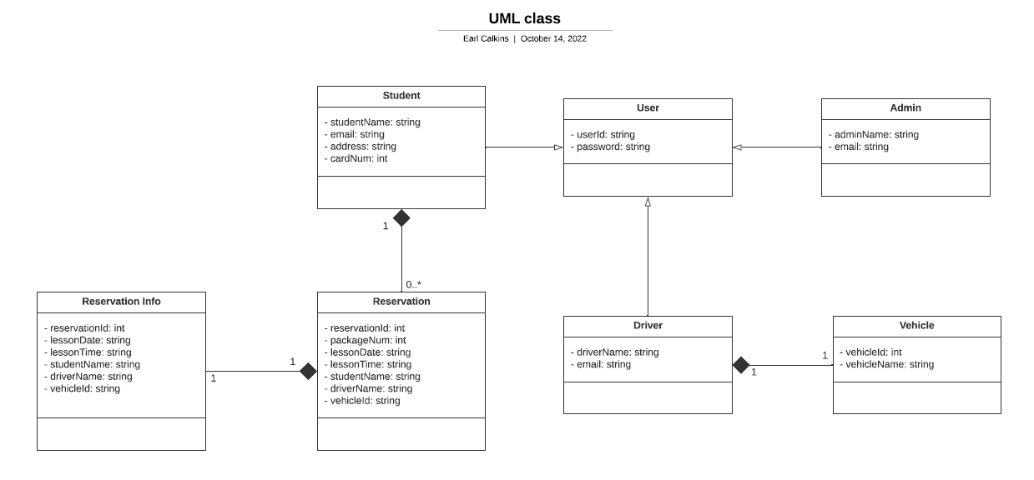

Technical Requirements
- Stable and responsive server for web-based operations
- Access to any relevant databases (Ex. DMV rules and policies)
- Secure login validation system
- Secure connection between client and server
- Storage for user accounts and reservation data
- Protection from malicious attacks via user input and other hacks
- User data stored in cloud storage and backed up frequently

